1. The (3, 1)-cofactor of the matrix is:

2. Suppose A is a 2x2 matrix with determinant 5. Find det(-3A-1)

3. What is the determinant of the matrix ?

4. What is the characteristic polynomial of the matrix

5. Find the eigenvalues of .

6. For what values of k is the set of vectors

S={(3,-2,5),(1,4,5),(2,k,-7)} linearly independent?

7. Find all values of k such that the set S is linearly independent

S = {(k,1,-1), (2,k,1), (-4,1,7)}

8. Let . Find

9. Let and $x=\left(m,-1,7\right)$.

Determine the value of m such that .

10. Let *u,v*∈R3 such that |*u|=3, |v|* = 7 and *u.v=5*. Find |3*u-2v*|.

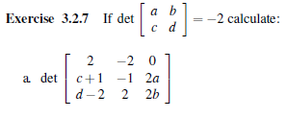

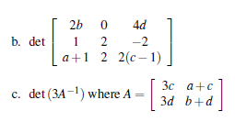

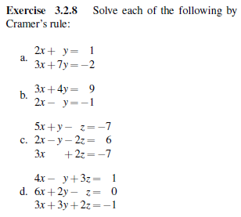

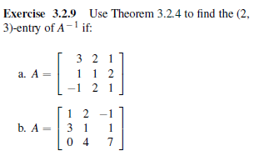

The (i,j) – entry of  is



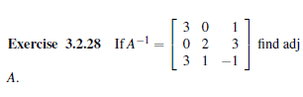



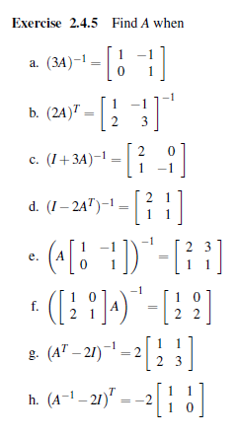

(A-1)-1 =A

